**17.Write a program to demonstrate switch, module, and include controllers in JMeter.**

**Switch Controller:**

First go to login page, enter username and password

https://the-internet.herokuapp.com/login

Go to below link,

https://the-internet.herokuapp.com/

Click on first link

Go to below link,

https://the-internet.herokuapp.com/

Click on second link

Go to below link,

https://the-internet.herokuapp.com/

Click on third link

Go to this page and click on logout button

<https://the-internet.herokuapp.com/login>

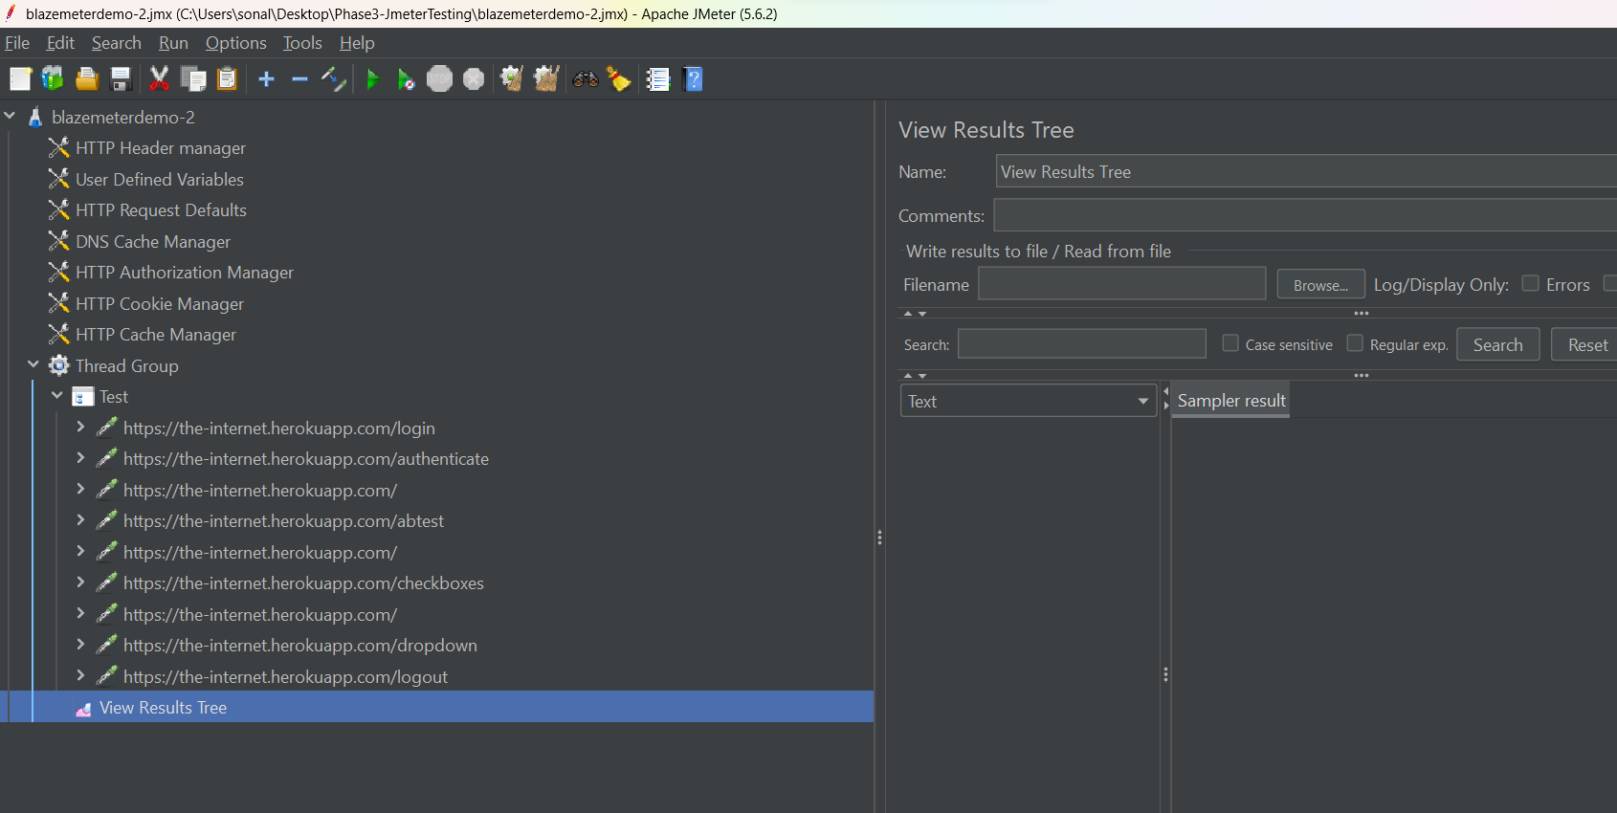

Place your samplers in Simple and Switch controller

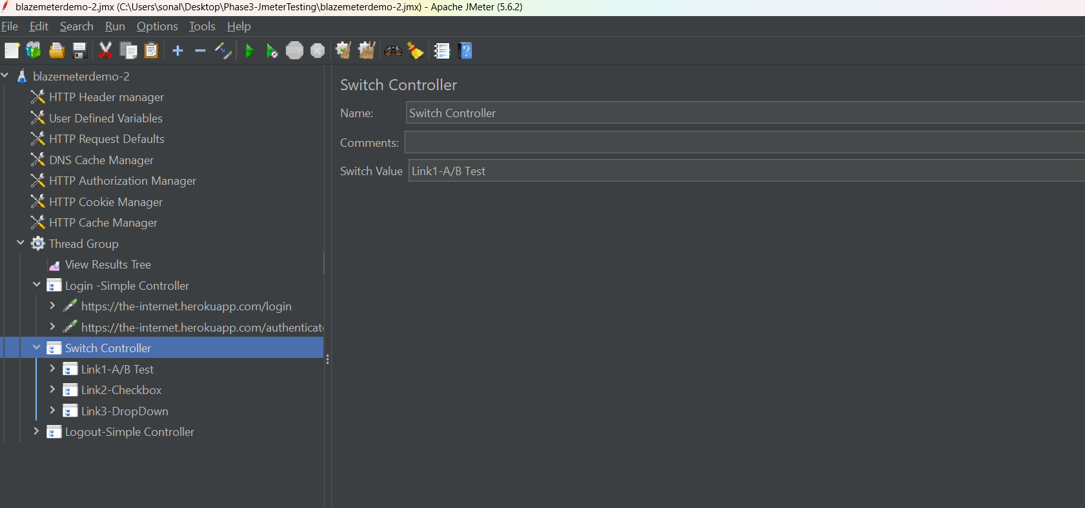

Give Switch value as one of the sampler.

Login 🡪 sample link1-A/btets will run 🡪 logout will run

Interleave Controller:

Precondition -> test1, test2, test3 🡪 post condition

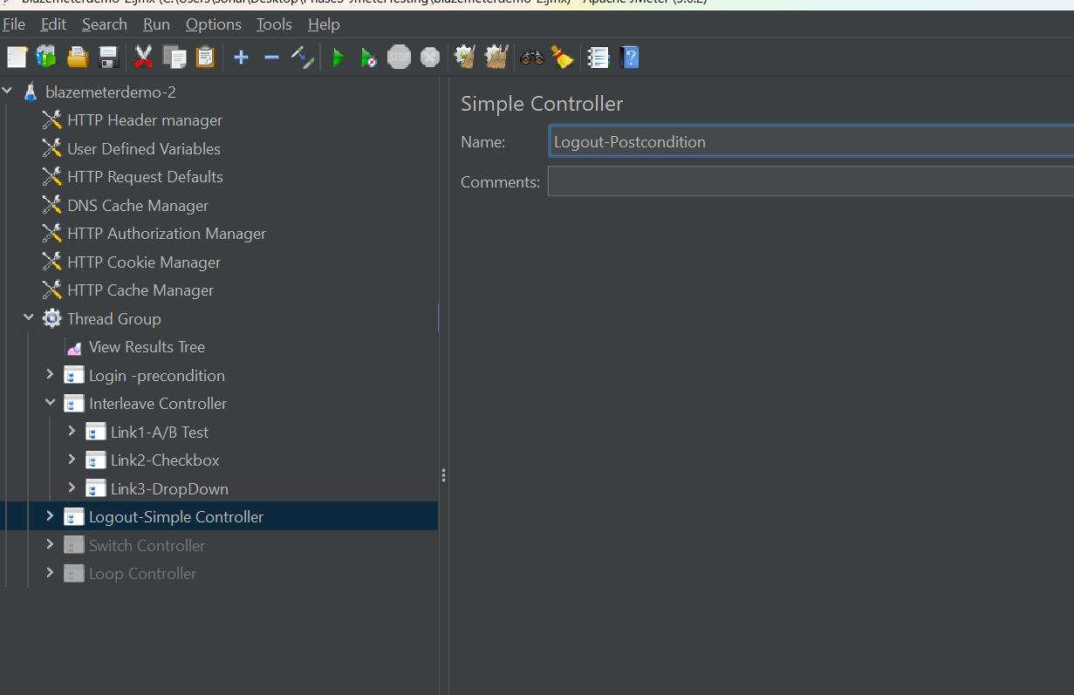

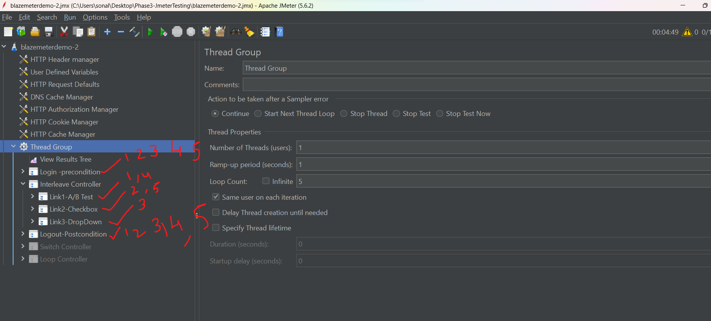

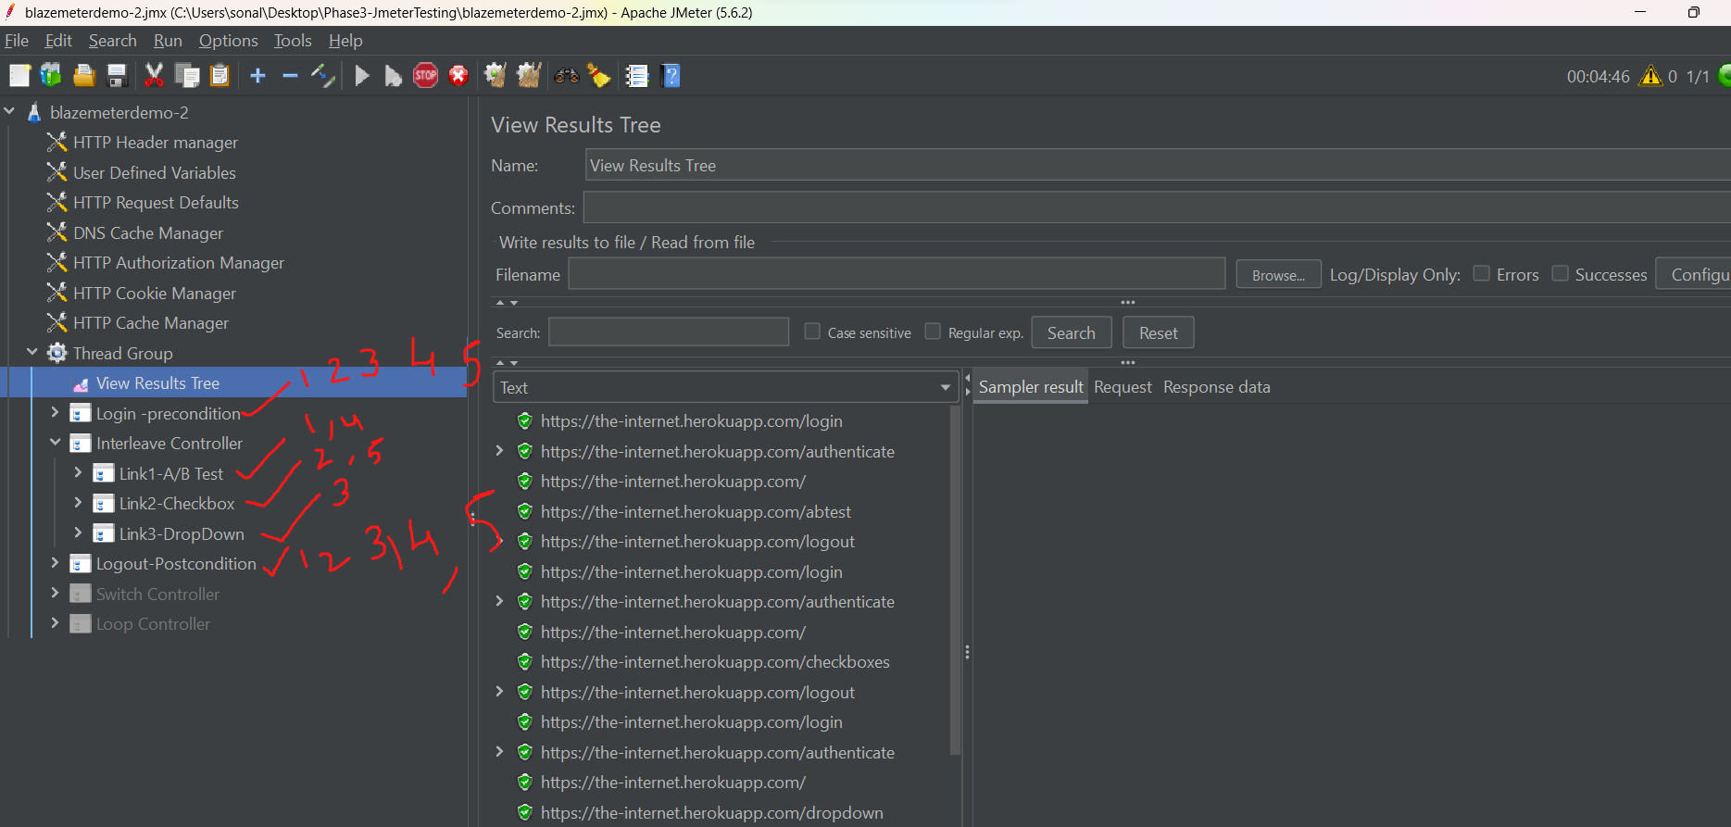

**Module Controller:**

In order to run many disabled controllers (state is disabled) at once, we can use module controller

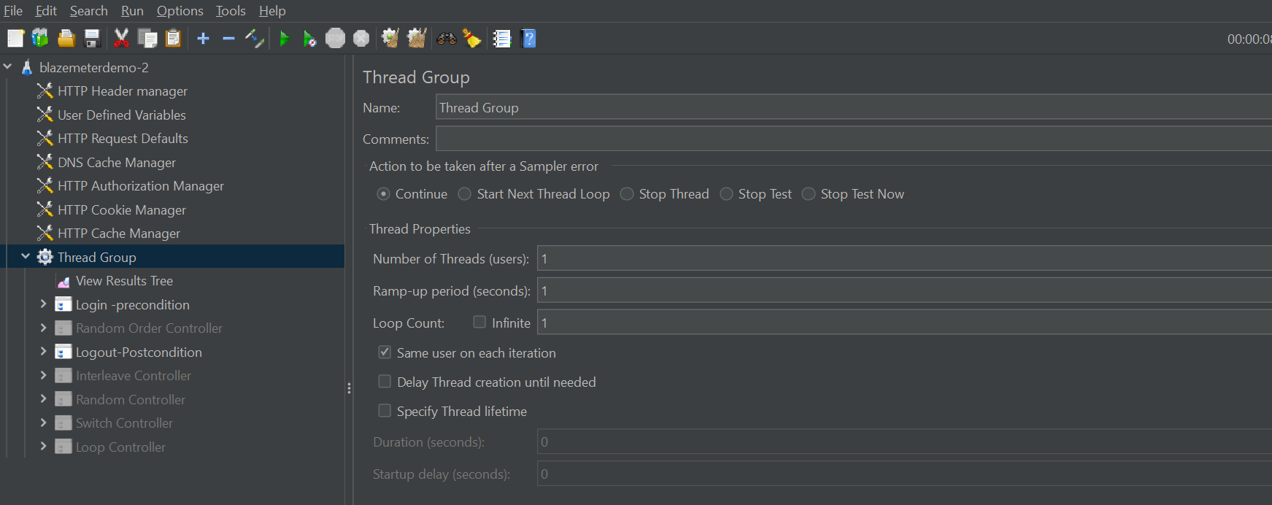

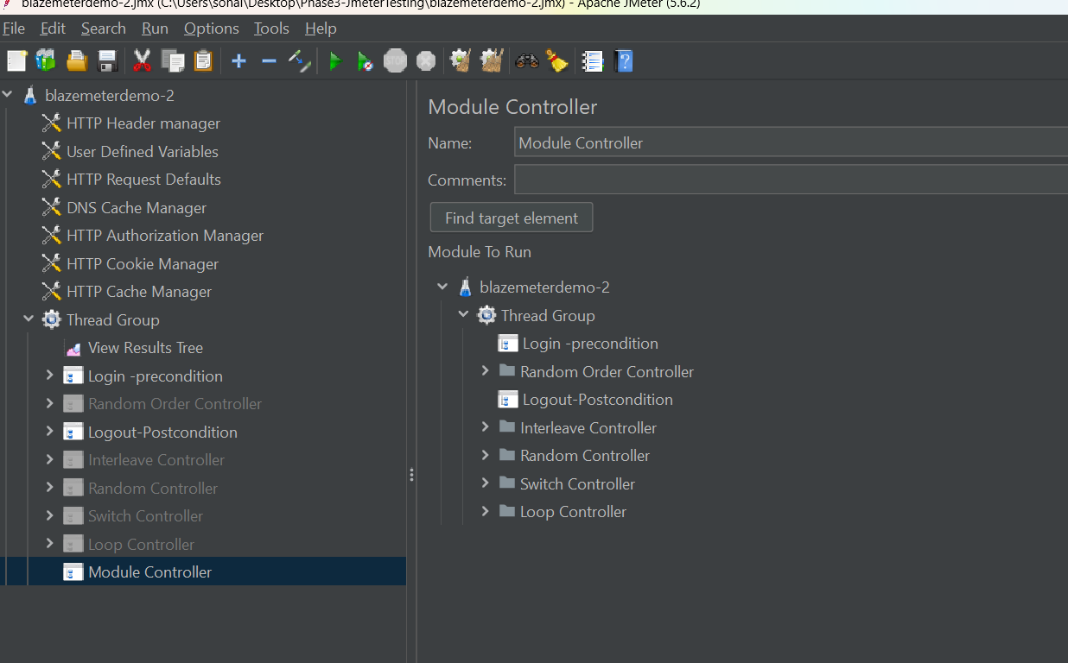

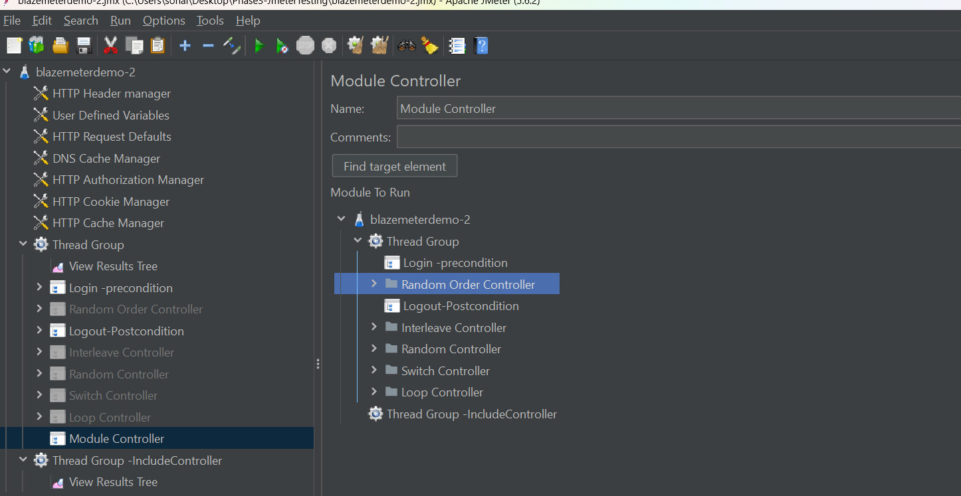

**Include Controller:**

Include Controller

Create a new Test Plan🡪Add a new Test Fragment

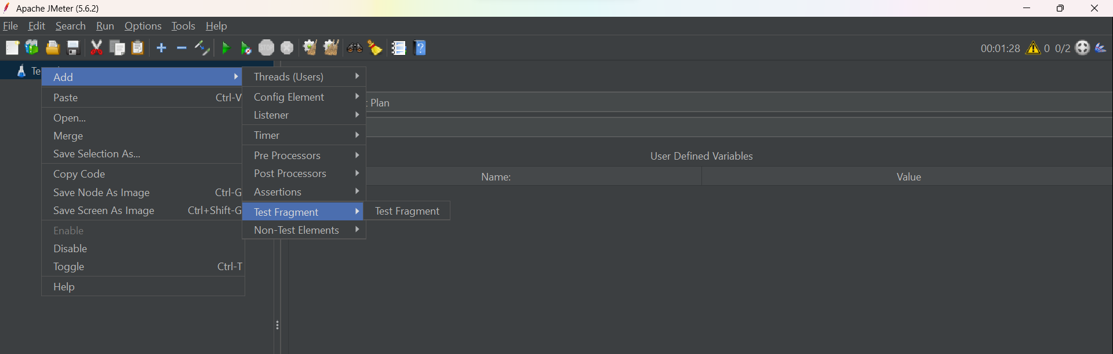

In Test Fragment🡪 add a HTTP sampler

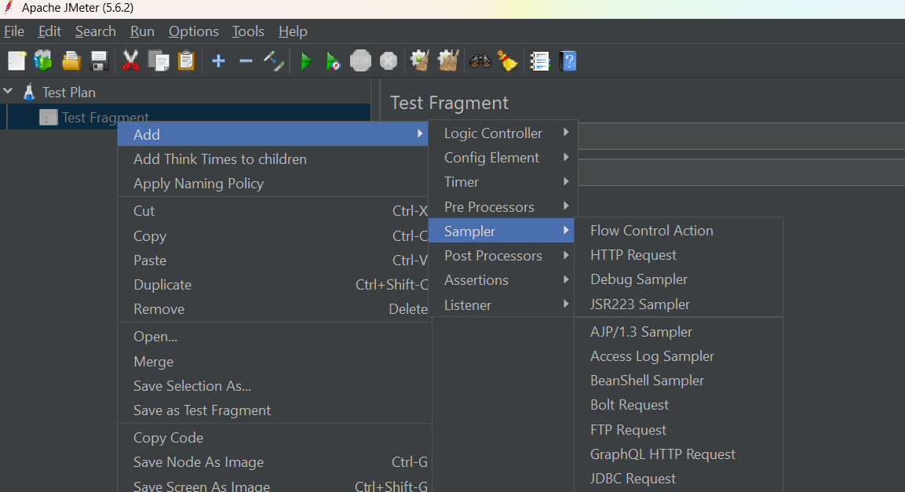

In the http request add blozedemo.com

Save the test plan as externelTest.jmx

Now open an exiting test plan 🡪 Add a thread group🡪add a include controller

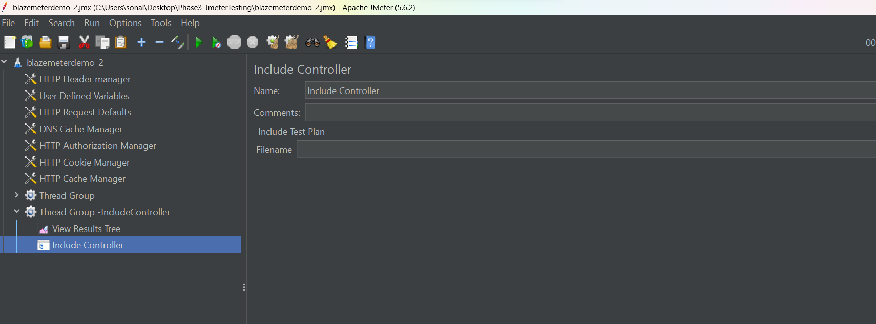

Underfile name click on browse button and select your script

